.
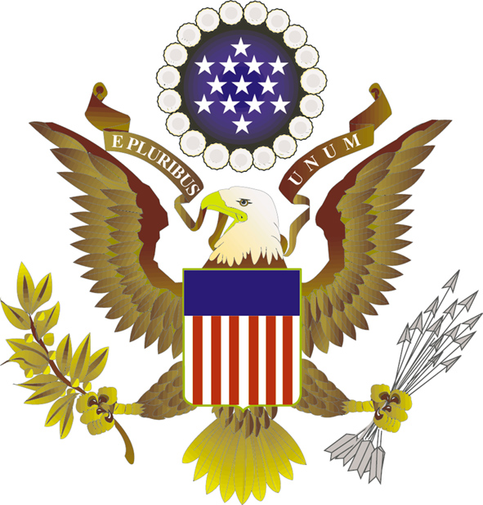

2015 New Generation Seminar
DRAFT SCHEDULE (likely to change)
Public Affairs Section
U.S. Embassy Seoul

June 26

DMZ tour with U.S. Korean War veterans
Orientation

August 24-29

First day
Opening Ceremony
Session I: Roundtable on “Meet and Greet with U.S. diplomats: A Look into the U.S. Embassy “
Session II: Lecture on “Smart Leadership”
Activity I: Tour of Ambassador’s residence
Welcoming Dinner

Second day
Activity II: Team Building Activity
Session III: “How to be an Effective Public Speaker””
Session IV: “All about ETS: Taking the TOEFL”
Session V: “Studying in the U.S. -Introduction to Education USA and Fulbright Scholarship Program”
Activity III: Art - Ansel Adams Exhibition
Debate Prep

Third day

Session VI: “U.S.-Korea Relationship though JUSMAG-K”
Session VII: “Drug Issues in Korea and the U.S.”
Session VIII: “Understanding Multinational Companies through 3M”
Session IX: “Think, Imagine, and Build”
Debate Prep

Fourth Day

Activity IV: Viewing of documentary film on the Korean War “Far From Forgotten”
Session X: Lecture on film “Far From Forgotten and Filmmaking”
Session XI: “Becoming Global: The story of Coca-Cola”
Session XII: “Franchising & Licensing American Brands (Dunkin Donuts, Jamba Juice, and Baskin Robins): SPC”

Fifth Day

Session XIII: “Understanding U.S. History through American Superheros”
Session XIV: “Being Korean-American: A Comparison of the U.S. and Korea”
Session XV: “The Art of Volunteerism: The Peace Corps/KOICA Experience”
Session XVI: “Tips in Preparing and Getting a Job”

HOMESTAY

Sixth Day

Activity V: Debate on “Are Leaders Born or Made?”
Closing Ceremony and Luncheon

