Ajou International Day 2014
“Ajou! It’s a small world!”

Ajou International Day will be held on November 6th (Thursday), 2014 on the Ajou university campus.

All international students are invited to participate in the Festival and enjoy diverse cultural activities at Ajou. This year’s event will include a variety of programs to help visitors and participants experience Korean culture firsthand.

The Festival offers a chance to explore various cultures of the world and enjoy an array of events and entertainment.

All international students at Ajou University are most welcome to join us!

“Join us for the Ajou International Day 2014!”
- Nov. 6th (Thu), 2014 -

- Date: November 6, 2014 (Thursday) 11:00am-6:30pm
* Orientation for the event will be held at 6:00pm on October 29th (Wed) (at the Yulgok Hall Auditorium) and further notification will be announced later.
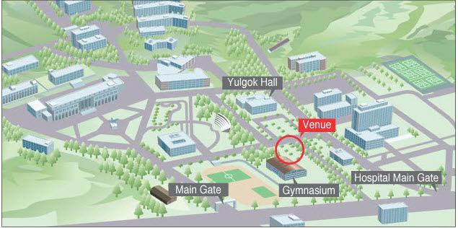
- Venue: Lawn behind the Gymnasium (Teletubby field)
- Eligibility: All Ajou international students enthusiastic about sharing their cultures with friends from across the world

4. Programs
Time | Programs
11:00 – 18:30  11:00 – 15:00  13:30 – 14:30  15:00 – 16:00  16:00 – 18:00  18:00 – 18:30  18:30 - | Ajou International Day 2014  World Food Festival and Exhibitions at booths  Opening Ceremony  Korean traditional martial art ‘Mu-ye 24 ki’  Group activities and performances of participating students  Ending performance and closing ceremony  Cleaning up
Cultural Workshops | Traditional Korean costumes  - Experience becoming a Korean traditional bride and groom  * Have your photo taken for a personal memento.  Traditional Korean games  - playing Neoltwigi (jumping on the seesaw board),  Tuho (throwing sticks into a barrel),  Jegichagi (kicking shuttlecock with feet)
- How to Participate

  - Food Festival - Booth Operation & Booth Exhibition
World Food Festival is the main event of Ajou International Day. International students of the same nationality can form one group and introduce their culture and tradition in the most creative manner. Each group will be given one booth to represent their country. You may cook traditional dishes, bring costumes, decorate the booth with objects indigenous to your country, or stage performances.

- Students can decorate the allocated booth with their traditional costumes and cultural decorative objects, and also play music to better introduce their cultures.
- Participating fee of 100,000 won stipend will be allocated to each group. You will be required to submit all receipts of any purchase made with the 100,000won and money left over will need to be handed back. More detailed info will be given at orientation. Due to lack of cooking facilities, simple, easy-to-prepare dishes are highly recommended.
- Visitors will buy the coupon on spot and students can sell the dishes at prices between 500 won and 1000 won.
- All visitors of the International Day will cast a vote for the best booth decoration and the best food, and 100,000 won will be given to the winner!
- Form a group with students from your country according to the guidelines below.

<Booth Operation Guidelines>
- A minimum of 2 international students are needed per group to be given a booth
- If no 2 persons are of the same nationality, then form a group with students with similar regional and cultural backgrounds
(i.g.) Guatemala & Ecuador → Central America
Tanzania & Kenya → East Africa
- 2 ~ 3 of Ajou students will be at each booth as a volunteer.
If you cannot locate any student of the same nationality as you, please submit the form and request to the OIA for an arrangement.
If you have classes on the day, you must individually ask for the professor’s permission and join the Festival. The OIA will issue the certificate of participation if necessary.

  - Performances
During the Festival, students will have a chance to present their skills such as traditional dancing, singing, costume parade and other programs designed to highlight traditions of their country. Any students who want to show their talents are welcome.

- Only group performances will be allowed. Groups organized with students from different countries are also welcome.
- Performances are optional. The best performing team will be selected and given a prize.
- The OIA will select the teams that most effectively introduced their cultures.
- Performance time: around 5 minutes per team
- Due to schedule of the international day, OIA will select 10 teams based on suitability for the festival.

- How to Apply
- Download the application form attached and send it to the OIA via email.
- Forms: Booth Exhibition Application / Performance Application
- E-mail : ajouevent@ajou.ac.kr (submission is possible only through e-mail)
- Due Date: October 22 (Wednesday) * Please keep the deadline to facilitate the process!

- Any questions?
Please make inquiries to Ms. Alice Lee and Hana Lee at the OIA.
Office of International Affairs (Yulgok Hall # 152)
E-mail: ajouevent@ajou.ac.kr
Tel: 031-219-2922 or 2923

Office of International Affairs (OIA), Ajou University

