Pre-arrival Information
Spring Semester, 2015

This pre-arrival information includes crucial information that will help you prepare your departure for Ajou!

  - Applying for Student Visa (D-2)

All international students are required to obtain D-2 (study) visas for their study at Ajou.

In order to obtain a D-2 visa, visit the nearest Korean Embassy in your country with the Certificate of Admission, Invitation Letter and Certificate of Scholarship (if applicable).
As required documents can vary for each country, check the required documents in advance with the Korean Embassy. Chinese students will need extra documents (refer to webpage at link).

Please note that you need to sign the Certificate of Admission issued by Ajou University before submitting it to the embassy. If you have already obtained another type of visa, you must change it to D-2.

For details on the visa process, visit our immigration information page:
www.ajou.ac.kr/en > International > Int’l Student Service > Immigration Information

- Dormitory Application

The final list for the spring room assignment will be posted on the official dormitory website in January 27, 2015.

University dormitory will open on February 24, 2015 for new coming students for the Spring 2015 semester. Please set your flight schedule to arrive after February 24. Unfortunately, it is not possible to move into the dormitory before the dormitory opening date.
If a student moves out of the dormitory early, the student is responsible for early move-out penalty fines.

For details on the housing application procedure, please refer to “Notice on Housing Application” sheet.

Before moving in the dorm residents should submit the result of the health check-up(TB) in English. The result must show normal or abnormal of TB in English. Without the result students cannot move in. Please send the TB results to grad@ajou.ac.kr until Feb 10th. Only after sending them applicants can print out dormitory bill.

For any questions about the dormitory, please contact Ms. Miran Kim, the dormitory coordinator at mirankim23@ajou.ac.kr

- Meals & Food

Students can buy various types of meals on and off-campus, and also cook some instant snacks in the shared kitchen of the dormitory. Students usually use the kitchen to cook noodles, toast, and small snacks or to keep their own food in the communal refrigerator. Normal meal prices range from 3,500 won to 5,000 won (approx. US$ 3~5) per meal.

- Course Registration

Course registration will be available online on Feb 10-16, 2015.
The tentative course list will be announced on our website, and the final list will be uploaded in early February.

Course list: http://goo.gl/4cZcx1
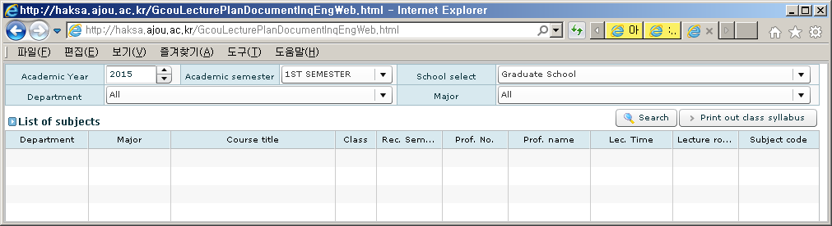
*Choose the department and major and click search button for subject the list.
- Course registration : Feb 10th ~ 16th, 2015
- Commencement of semester : Mar 2th
- Course Change(Add & Drop) : Mar 5th ~ 9th, 2015
- Course Withdrawal : Mar 25th ~ 27th

- Re-test for TB at the district public health center in Korea

Please note that according to government regulation, students from certain designated countries will need to get re-tested for tuberculosis at the district public health center in Korea upon arrival.

The designated countries are: China, Sri Lanka, Russia, Uzbekistan, Thailand, Vietnam, India, Nepal, Indonesia, Pakistan, Mongolia, Bangladesh, the Philippines, Myanmar, Cambodia, and Malaysia.

More detailed information will be announced at orientation, but students from the above countries should be aware of this necessary process upon arrival.

- Arrival to Ajou University from Incheon Int’l Airport

Airport pick-up service

Airport pick-up service is available only for students who apply for it in advance. Airport pick-up service is available for two days (Feb 24 and 25, 2015) prior to orientation only at Incheon International Airport.

In order to use this service, you need to complete a survey on your arrival info by clicking on the link below: https://ko.surveymonkey.com/s/Arrival2015. The deadline for pick-up service application is Feb 10, 2015.

Ajou students will pick you up at the airport between 9:00 am and 8:00 pm on February 24 and 25. When you arrive at the airport, please wait for the A.G.A. students (Ajou Global Ambassador: student volunteer group) inside of Exit No. 7. (Please don’t leave the airport.)

A.G.A. students (Ajou Global Ambassadors) will be holding an “Ajou University” sign in front of Exit No. 7 on the 1st floor and will guide you to the limousine bus heading to Ajou University.

Students arriving on their own

Please refer to the information below for directions from Incheon International Airport to Ajou University. If you are staying in the dormitory, please go directly there and check-in with the dormitory coordinator.

- Arrival at Incheon International Airport (International Arrival, 1st floor)
- Go to EXIT No. 7 (International Arrival, 1st floor)
- Take the airport limousine bus toward “East Suwon” at 7A Bus Stop (Gyeonggi).
(Fare: 12,000 Won / about US$ 10)
- Get off at the last bus stop, “Hotel Castle”
- Take a taxi to Ajou University from Hotel Castle. (about 3,000 Won/ US$ 3)

“아주대학교 기숙사로 가주세요”
“Please drive me to the dormitory of Ajou University.”
- Bus tickets are sold at the airport, but the driver will also accept the fare directly when you board.
- Do NOT take a taxi directly from the airport as the fare from the airport to the university will be very high.
- Incheon Airport information Desk: +82-(0)32-741-0114 (http://www.airport.kr/eng )
- Emergency Contact : Office of International Affairs, Ajou University
Tel: +82-(0)31-219-2922, 2923, 2171, 2172, E-mail: incoming@ajou.ac.kr

- Orientation

All international students are required to attend the orientation. The Office of International Affairs will be there to meet and to assist you with any questions you may have for staying at Ajou University.

During the orientation, important information such as academic schedule, alien registration, health insurance and tips for living in Korea will be introduced to prepare you for life in Korea. A campus tour and welcoming reception will follow the orientation.
Session 1: Orientation for ALL New International Students
(including New Graduate Students)
Date: 10:00am to 1pm, February 26 (Thu)
Venue: Auditorium, Yulgok Hall
Session 2: Orientation for New Graduate Students
(excluding GSIS)
Date: 1:30 pm to 2:00pm, February 26 (Thu)
Venue: #253, Yulgok Hall

- Health Insurance Policy at Ajou

All International students studying at Ajou University are required to purchase health insurance. The insurance must cover the full study period, from the date of arrival to the date of departure.

Students can purchase health insurance from their home countries, or they can purchase it through the Office of International Affairs (OIA) at Ajou. As OIA has a contract with an insurance provider, it is recommended that you purchase insurance through the OIA at the discounted price.

If you plan to purchase the insurance at Ajou University, you are required to apply online at www.foreign-insurance.kr. After online application, you need to pay the insurance fee directly to the insurance company upon arrival at Ajou, and detailed information will be given at the orientation.

We ask that students submit the copy of the insurance contract within the first week of the semester. If a student does not submit a copy of the health insurance, the issuance of documents such as transcripts, Certificate of Enrollment, etc., will be restricted.

Before you purchase the insurance, please read the enclosed “Insurance Policy at Ajou” and the insurance information below at:
www.ajou.ac.kr/en > International > Int’l Student Service > Health Care

- Alien Registration
All students who stay in Korea for more than 90 days must apply for the alien registration card within 90 days of entry. It usually takes 3-4 weeks for the card to be issued.
On-campus immigration service will be provided for one day in the beginning of the semester for all new foreign students. More detailed information on this schedule will be announced at orientation.

Photo (3*4 size, plain background) should be prepared.

- To open a bank account
If you would like to open a bank account in Korea, you will need your home country ID card such as residential identification or driver’s license and/or your passport and Ajou student ID card.

Office of Graduate School (Yulgok Hall # 305)
Ajou University
206 Worldcup-ro, Yeongtong-gu, Suwon 443-749, Korea
Tel: +82-31-219-2922, 2923 Fax: +82-31-219-2924
E-mail: grad@ajou.ac.kr
Website: grad.ajou.ac.kr, grad-e.ajou.ac.kr
KakaoTalk : makeiteasy

Office of International Affairs (Yulgok Hall # 152)
Ajou University
206 Worldcup-ro, Yeongtong-gu, Suwon 443-749, Korea
Tel: +82-31-219-2922, 2923 Fax: +82-31-219-2924
E-mail: incoming@ajou.ac.kr
Website: www.ajou.ac.kr/en
Facebook: www.ajou.ac.kr/facebook

