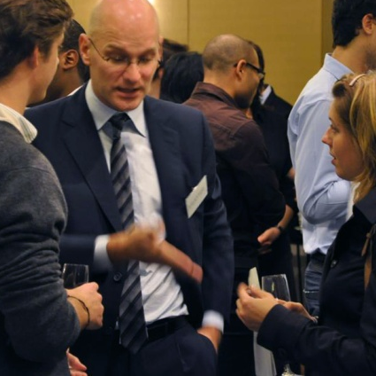






Booking Form

EVENT: Open Discussion & Cocktail
DATE: Tuesday, June 7th 2011 - 6:30pm to 9:00pm
VENUE: Grand Ambassador Seoul, Orchid Hall, 19th floor
PRICE: KRW 49,000 for members
KRW 64,000 for non-members
KRW 26,000 for students (part of participation fees have been covered by our generous sponsors)

IMPORTANT: - If you are willing to sponsor the event, please contact Ms. Yuri KIM by phone: 02)2268-9505(ext.107) /email: event@fkcci.com

Attention students!
This event is exclusively for French exchange students at Korean universities & Korean students with an economic/commercial/engineering background.

Company/University:
Name:
Title/ Major:
E-mail:

For registration please return this form by email: event@fkcci.com or fax 02) 2268-9508. Payment can be done either by cash, credit card or wire transfer to the FKCCI bank account (Korea Exchange Bank, n°065-22-02238-0). Transfer must be made 24 hours prior to the event. Cancellations must be notified by fax 24 hours prior to the event. After this deadline, cancellation and no-shows will be charged accordingly.

