
“ We invite you to Ajou International Day 2008!”

Ajou International Day will be held on November 6th (Thursday) at Ajou university campus.

All international students are invited to participate in the Festival to bring diversity to Ajou Campus.

During the festival, you can have a chance to experience various cultures introduced around the world and can enjoy many other cultural events.

All International students at Ajou University are warmly welcomed to join in the festival!!

- Date : 2008. 11. 06(Thursday) 10:00 ~ 17:30
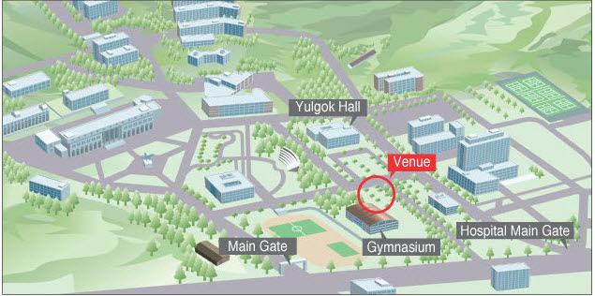
- Venue : Lawn in front of Yulgok Hall

- Eligibility : Passionate international students who want to share their cultures with other people.

- How to participate in the festival!!
International students form one group with students from their own country and have own booth to represent their country. During the festival, students can introduce their traditional food, costumes, cultural decoration and cultural performance.

  - Booth Operation & Booth Exhibition
    - Make a group with students in your country according to the guideline below.
    - Fill out the “Booth Application form of Ajou International Day 2008” attached above.
    - You can decorate the booth with your traditional costumes, cultural decoration, songs and others to introduce your country and culture.
<Booth Operation Guideline>
    - At least 3 international students in one booth
    - If a group has less than 2 people in one country should make one group with students from another country from similar cultures
i.g. U.S.A & Canada > North America
Guatemala & Ecuador > Central America
Tansania & Kenya > East Africa

  - Food Preparation
    - Due to lack of cooking facilities, simple but popular food is recommended
    - 100,000 won of Booth preparation fee will be given to each group.
International Day Winner goes to the best booth & food
All visitors to the International Day will vote for the best booth and the best food, and the 100,000 Cash will be offered to the winner!

  - Performance
    - During the festival, students will have a chance to introduce their skills to the community such as traditional dancing, singing, performance, costume parade and many others according to students’ preference and skills.
    - Individual or group performance will be all welcomed.
    - Fill out the attached “Performance Application form of Ajou International Day 2008”
    - Performance is optional.(only individual or group who wish to perform!)

- Program
Time | Program
09:30 ~ 11:30 | Preparation (Food and etc)
11:30 - 12:00 | Opening Ceremony  - Congratulatory Performance  - Opening Remarks  - Congratulatory Remarks
12:00 ~ 17:30  12:10 ~ 15:00  15:00 ~ 16:00  16:00 ~ 17:00  17:00 ~ 17:30 | Ajou International Day 2008  - Food Festival & Games  - Participants’ Performance  - Group Activity & Ending performance  - Awards & Closing  - Wrap-up

- How to Apply
    - Download the application form attached and send the form(booth, performance application) to GSIS(gsis@ajou.ac.kr)
    - Due Date: Oct. 23(Thursday)
** Sorry for the hurry! But please keep the deadline for fine process!

- Any questions? Please ask Ms. Miyeon Chung(gsis@ajou..ac.kr), coordinator of GSIS, OR Ms. Minty (incoming@ajou.ac.kr) from Office of International Affairs

Graduate School of International Studies & Office of International Affairs

