Eco-tour in Gyeonggi-Do, Korea(Free Tour)

This is free tour for foreigners in Ajou University. All costs will be charged by Gyeonggi Tourism Organizations. Visit Gyeonggi-do and Experience beautiful nature in Korea! Anyone who want to participate, email us the form filling out at joon@gonseekorea.com or samhoon@gto.or.kr. If you have any inquiry, feel free to contact us!

Contact :
Email joon@gonseekorea.com, cell-phone 010-6219-8506
Email samhoon@gto.or.kr, cell-phone 019-317-4043
Participation Application Due Date : 2008. 9. 23(Sep. 23, 2008, by e-mailing application form)
Tour Date : 2008. 10. 3(Oct. 3 2008, first come first served 20 people)
Tour Itinerary
Time | Destinations | Activities
09:00 | Seoul City Hall | Departure from Seoul City Hall
09:00~10:20 | Bus | Move to Haewoojae(via Ajou Univ. pick up for Ajou Univ. Student. 10:10)
10:20~11:00 | Haewoojae(Suwon) | See Toilet House, Haewoojae
11:30~12:00 | Suwon Resource recovery center | See around Resource recovery center
12:00 ~ 12:30 | Bus | Move to
12:30~~13:30 | Luncheon | 갈비정식(Galbi)
13:30~14:30 | Bus
14:30~16:30 | Sihwa Reeds Wetland Park(Ansan) | See aquatic plants and reeds
16:30~17:30 | Bus | Move to Seoul City Hall and Dismiss

<Tour Destinations Information>

수원 해우재(Haewoojae, Toilet House)
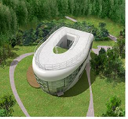 | Haewoojae, which means 'house to appease worry,' was built by World Toilet Association Chairman Shim Jae-deok. Haewoojae is listed in the Guinness Book of Records as the world's largest toilet-shaped structure. It conveys the importance of the toilet as a valuable living space by locating toilets at the center of the structure. In each toilet, water-saving devices are installed that reduce water consumption by 70%. The structure uses sustainable resources through its solar light generation system and rain water storage tank.

수원 소각시설(Suwon Resource Recovery Facility)
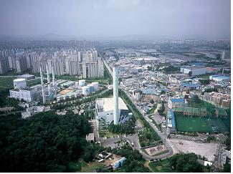 | The Suwon Resource Recovery Facility treats all waste materials generated in Suwon. The polluting materials generated from the operation of the facility are monitored through an automatic measuring system for gas emissions and disclosed to local residents on real time basis through electric signage. Furthermore, a 6-level convenience facility with an area of 7,181㎡ offers swimming, health, aerobic and education programs to residents at a minimal cost

안산시화호습지공원(Ansan Sihwa Reed Wetland Park)
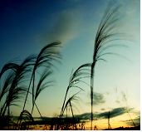 | A large-scale artificial wetland that afforested by aquatic plants such as reeds so as to treat waste water flown to Sihwa Lake. the Park is composed of the Ecosystem Hall, the Ecosystem Observation Facility and the Wild flower Road as well as the artificial swamp. Visitors can observe various aquatic plants following the 1.7km-long tree-deck promenades.

